# **CTF Topic: Vulnerability Assessment**



# **Introduction**



Vulnerability scanning is the process of identifying security weaknesses and flaws in systems and software running on them. It’s an essential part of a vulnerability management program, designed to protect organizations from data breaches and the exposure of sensitive data.

# **Tools and requirements**

Nikto online

# **Link**

<https://nikto.online/>

# **Scenario**

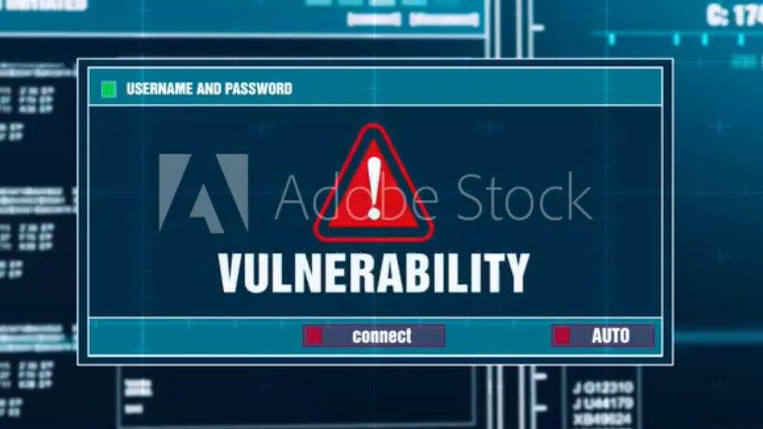

ING skill academy launched the bug bounty program worth 1 lakh rupees. So, ram had scanned the domain name of the ING skill Academy and found the vulnerabilities.

# **Process to Perform**

To perform this process you have to go to the link given below and scan **rest.vulnweb.com**

<https://nikto.online/>

# **Let’s start the Challenge**

# **Question**

Flag 1: Which server and version used by the website?

Answer: Apache/2.4.25

Flag Captured.

Flag 2: Which header is not set?

Answer: X-Content-Type-Options

Flag Captured.

# **Hint**

